PRAKTIK PEMROGRAMAN WEB

LAPORAN LATIHAN



Disusun Oleh :

Putri Safira Salsabilla

19520244001

PROGRAM STUDI PENDIDIKAN TEKNIK INFORMATIKA

FAKULTAS TEKNIK UNIVERSITAS NEGERI YOGYAKARTA

2020

**27 Februari 2020**

1. **Materi Yang Telah Dipelajari**

* Membuat desain layout.
* Membuat desain background (background warna, background gambar).

1. **Coding**

|  |
| --- |
| #wrapper {  margin: auto;  width: 750px;  border: 1px solid red;  }  #header {  height: 80px;  border: 1px solid blue;  }  #inner {  float: left;  margin: 5px 0;  border: 1px solid black;  }  #sidebar {  float: left;  margin-right: 20px;  width: 180px;  height: 330px;  border: 1px solid red;  }  #content {  float: left;  width: 544px;  height: 330px;  border: 1px solid green;  }  #footer {  clear: both;  height: 50px;  border: 1px solid blue;  } |

|  |
| --- |
| <!DOCTYPE HTML>  <html lang="id">  <head>  <title>Desain Layout Sederhana</title>  <link rel="stylesheet" href="mystyle.css" type="text/css" />  </head>  <body>  <div id="wrapper">  <div id="header">  Header  </div>  <div id="inner">  <div id="sidebar">  Sidebar  </div>  <div id="content">  Content  </div>  </div>  <div id="footer">  Footer  </div>  </div>  </body>  </html> |

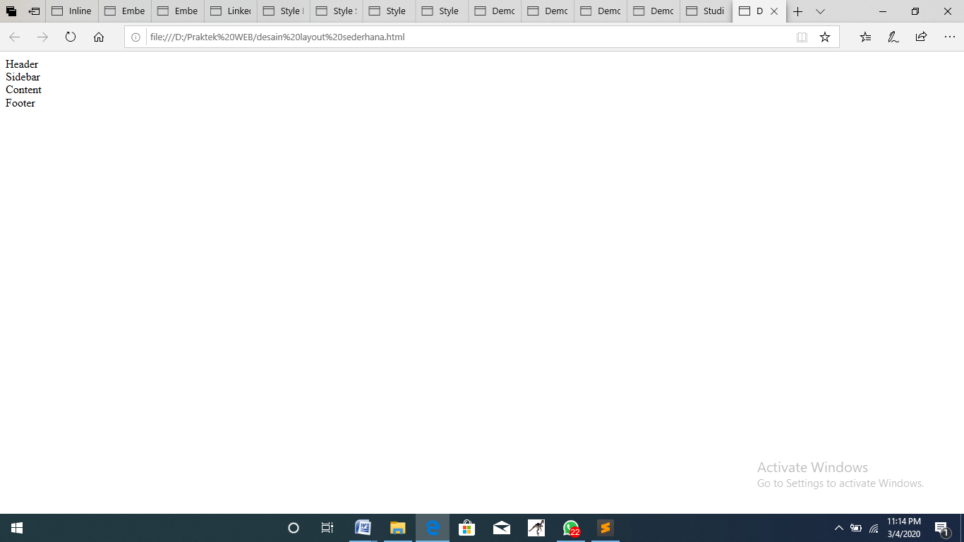

|  |
| --- |
| body {  margin: 10px auto;  width: 750px;  }  header,nav,section,footer {  display:block;  border:1px solid blue;  }  header{  height:80px;  }  nav{  float:left;  width:200px;  height:370px;  }  section{  margin-left:200px;  width:500;  height:370px;  }  footer{  clear:both;  height:20px;  } |

|  |
| --- |
| <!DOCTYPE HTML>  <html lang="en">  <head>  <title>Desain Layout Sederhana HTML5</title>  <link rel="stylesheet" href="mystyle2.css" type="text/css" />  </head>  <body>  <header>  header  </header>  <nav>  nav  </nav>  <section>  section  </section>  <footer>  footer  </footer>  </body>  </html> |

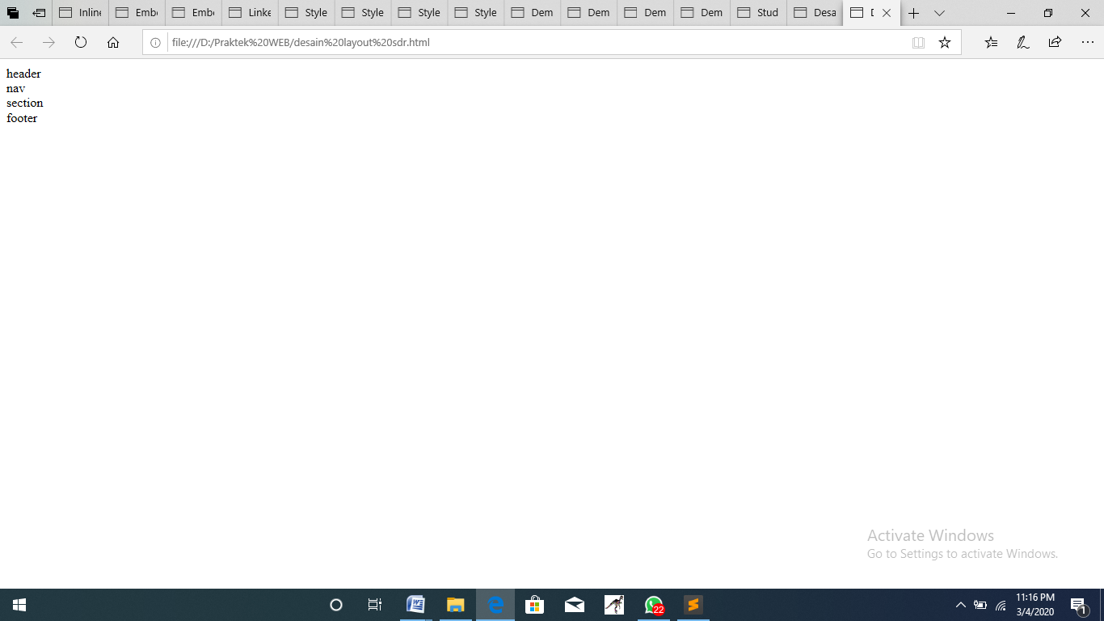

* **Desain background**

|  |
| --- |
| <!DOCTYPE html>  <html lang="id">  <head>  <title>Desain Background</title>  <style>  body {  background-color: pink;  margin: 10px auto;  width: 750px;  }  header {  display: block;  border: 1px solid blue;  }  header {  height: 120px;  }  </style>  </head>  <body>  <header>  header  </header>  </body>  </html> |

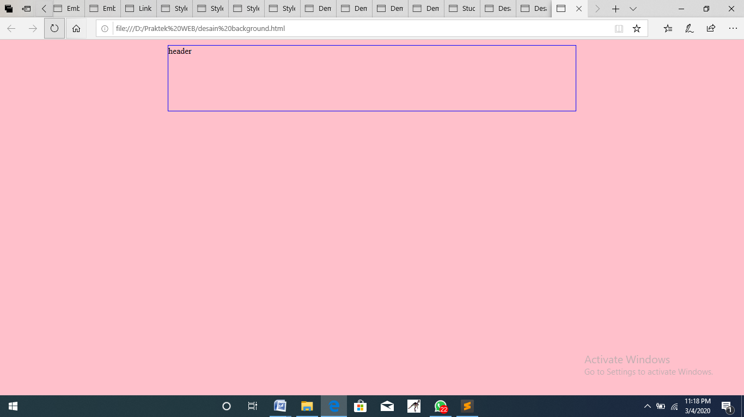

|  |
| --- |
| <!DOCTYPE html>  <html lang="id">  <head>  <title>Desain Background</title>  <style>  body {  background: yellow url("LOGO UNY.png");  margin: 10px auto;  width: 750px;  }  header {  display: block;  border: 1px solid blue;  }  header {  height: 120px;  }  </style>  </head>  <body>  <header>  header  </header>  </body>  </html> |

